AWS task 2 VPC Creating

Task is to create a VPC, subnet, IG and launch an EC2 instance within that VPC  
  
  
Step: 1 VPC Created

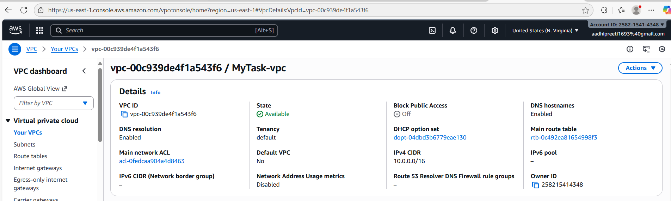  
  
Step 2: Subnet Created

/24 creates 256 IPs

Public Subnet

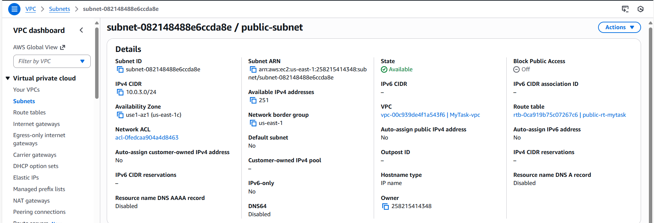

Private Subnet

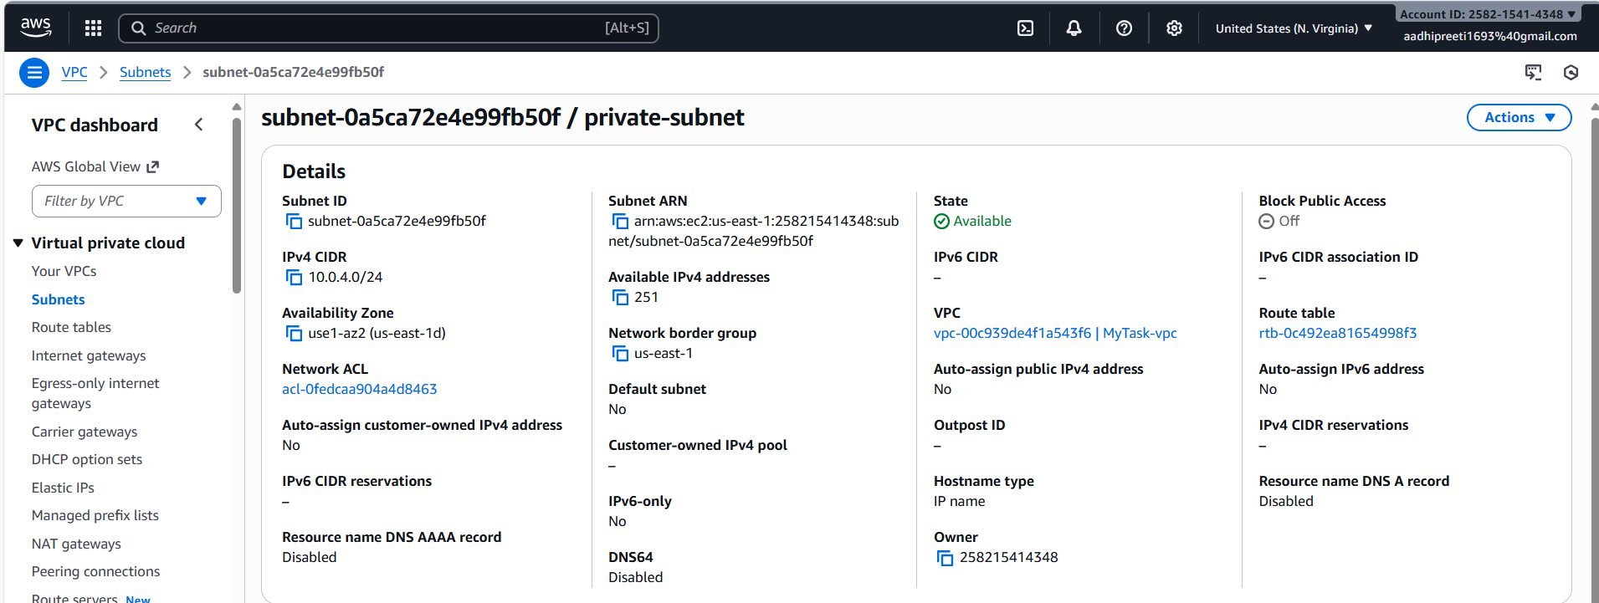

Step 3: Internet gateway created

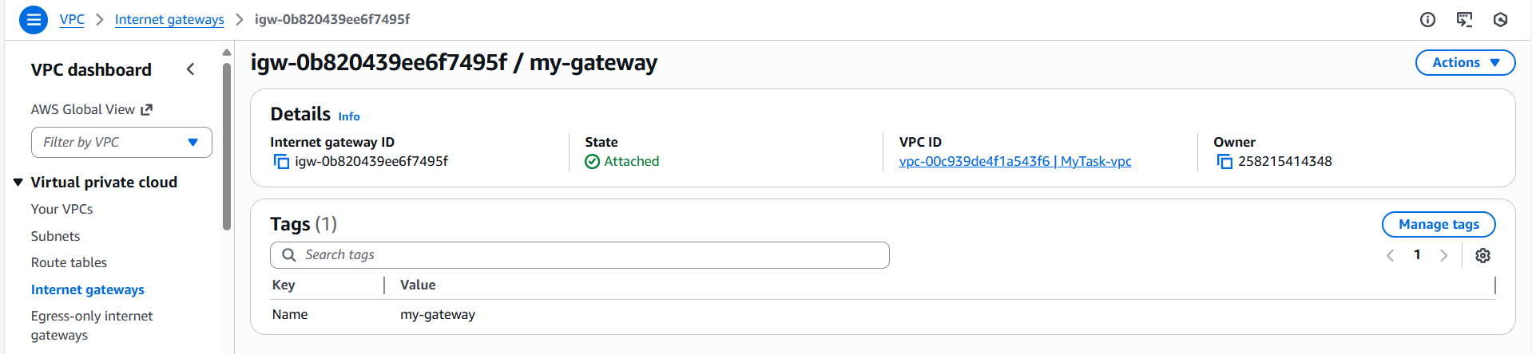

Step 4: set routing Tables

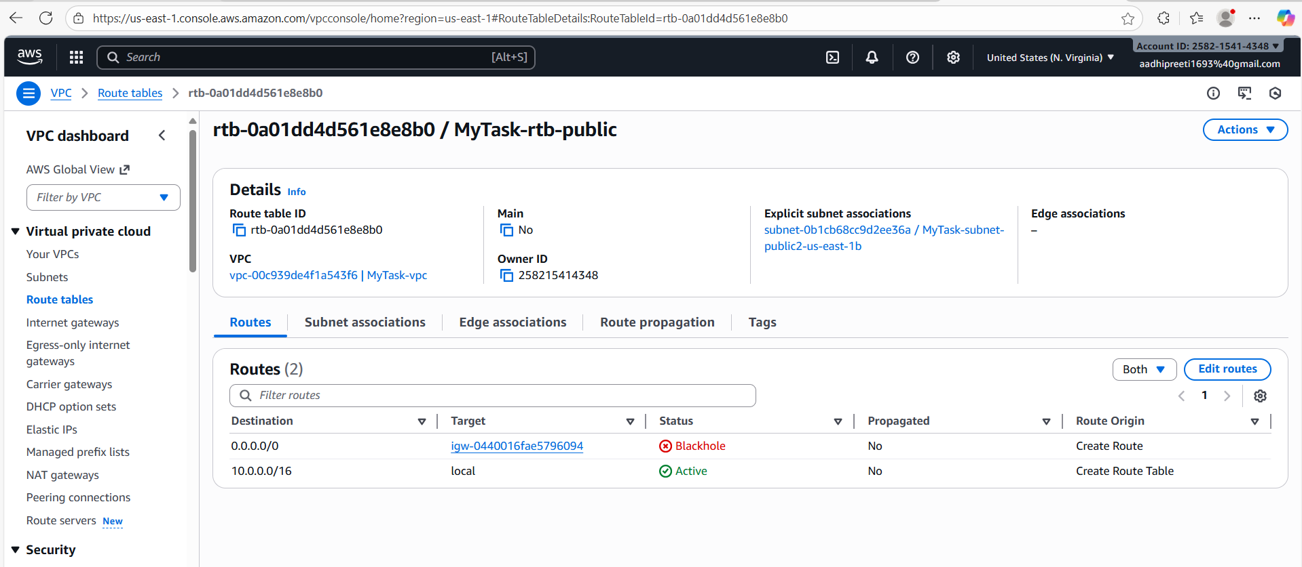

Step 5: EC2 instance launched within this VPC

